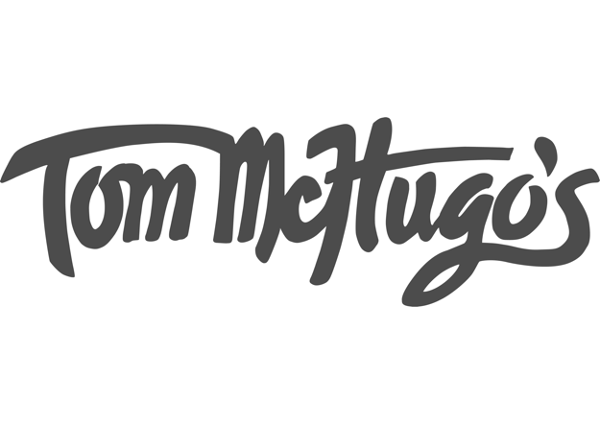

Snacks
Oyster Province Angasi 4/22 Hot sauce or Natural
Cheesebreads 8
Bean fritters with fermented turnip kasoundi 10
Rockytop farm cabbage curry puff with pickled lemon chutney 12
Fried black pepper chicken 12
Haggis bao with chili oil 12

Vegetables (not always vegetarian)
Braised Kindred organic spelt with fennel cream, preserved greens and aged cheese 14
Newry farm asparagus with lactic curd cheese, chervil and chives 14
Roasted carrots with mustard kefir cream and sweet cicely 12
Silverbeet, Swiss chard and cheddar mornay 12
Meat dishes
English longhorn bone marrow with kuri squash miso and toast 15
Steamed beef shin dumplings with fermented cabbage and broth 18
English longhorn pastrami sandwich with pepper gravy and chips 16
Littlewood farm lamb mince and black pepper pie with mushy peas and gravy 18
Lambs’ tongue with chicken broth, laksa leaf, shungiku, mint and turnips 20
English longhorn beef rump with McHugo’s herb butter and chips 24
Chicken parmy with chips 15
Chicken schnitzel with chips 15
+ Herb and mustard butter 2
+ Green peppercorn sauce 2
+ Mushroom sauce 2
+ Wholegrain Irish ale mustard 1

Sides
Sauteed greens with rosemary and garlic vinaigrette 6
Salad leaves with mustard dressing 5
Garlic bread 7
Chips 8

Desserts
Brewers malt pie with malt cream 10
Crème caramel 8
Fried apple pie 12

